**DBMS Group Mini-Project**

**Employee Management System**

**Team Members :**

**Dhruv Ladia(RA1911003010550)**

**Sagar Bhardwaj(RA1911003010552)**

**Ishita(RA1911003010560)**

**Abstract :**

Employee Management System Project is an essentially software designed to keep track of employee information in any company. It stores data such as their employees' personal information. The goal of "Employee Management System" is to create a work center scheduling system. Scheduling is a technology that makes the process of informing activities and notifications in the company where it is implemented simple and even online.

The Employee Management System project gives managers a better idea of their employees and helps them plan and manage their work hours in order to cut costs and boost productivity. It gives appropriate directions and supervisions for employees. It also secures and manages information that are important to the employees including personal and work-related information.

**Scope :**

The DBMS is a really powerful set of tools, enabling users to operate easily with data into a database as: Inserting, Updating, Deleting and Retrieving data. It prevents unauthorized access to the database and maintains the consistency of the stored data. The DBMS also restores the data in case of hardware or software failure and reduces the loss of data in this way.The logical database model (tables, their content and the relationships between them) should respond to the given task and cover the basic requirements. The Interface of the program should be user-friendly, and the program should be as easy for use as it is possible. Both controls and forms should logically and functionally be related within the program and fully respond to the structure of the database. Another problem is establishing the connections with the database, every time, when a query is needed to be performed upon it. Exception-handling should also be taken into an account during the system’s development due to eventual exceptions that may occur.

You can have all employees' profiles centralized in one single web-app, organized, and well structured. Now it is easy to filter, check the status, and see where things got stuck. This software means less time doing paperwork and much more time focusing on people.

**Techs and Tools used :**

* Flutter
* MySql
* Xampp Server
* Vs Code

**ER Diagram :**

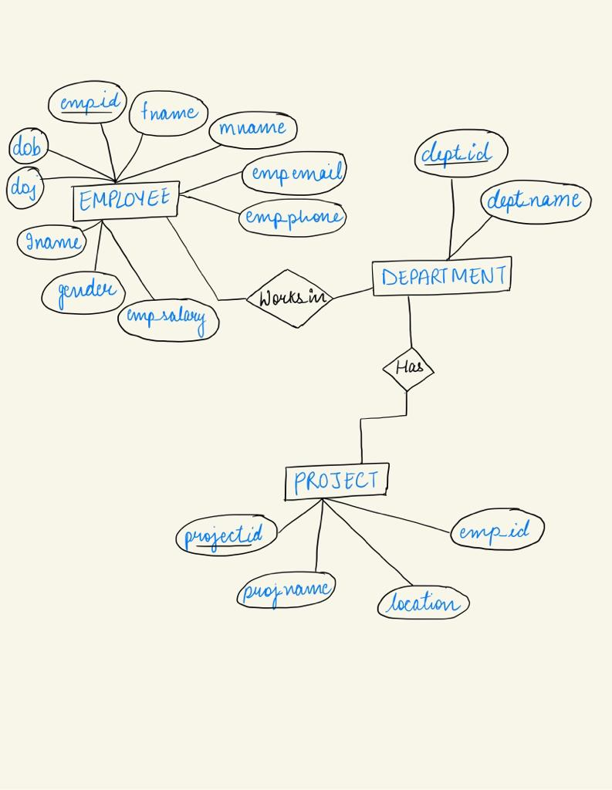

**Github Screenshot :** 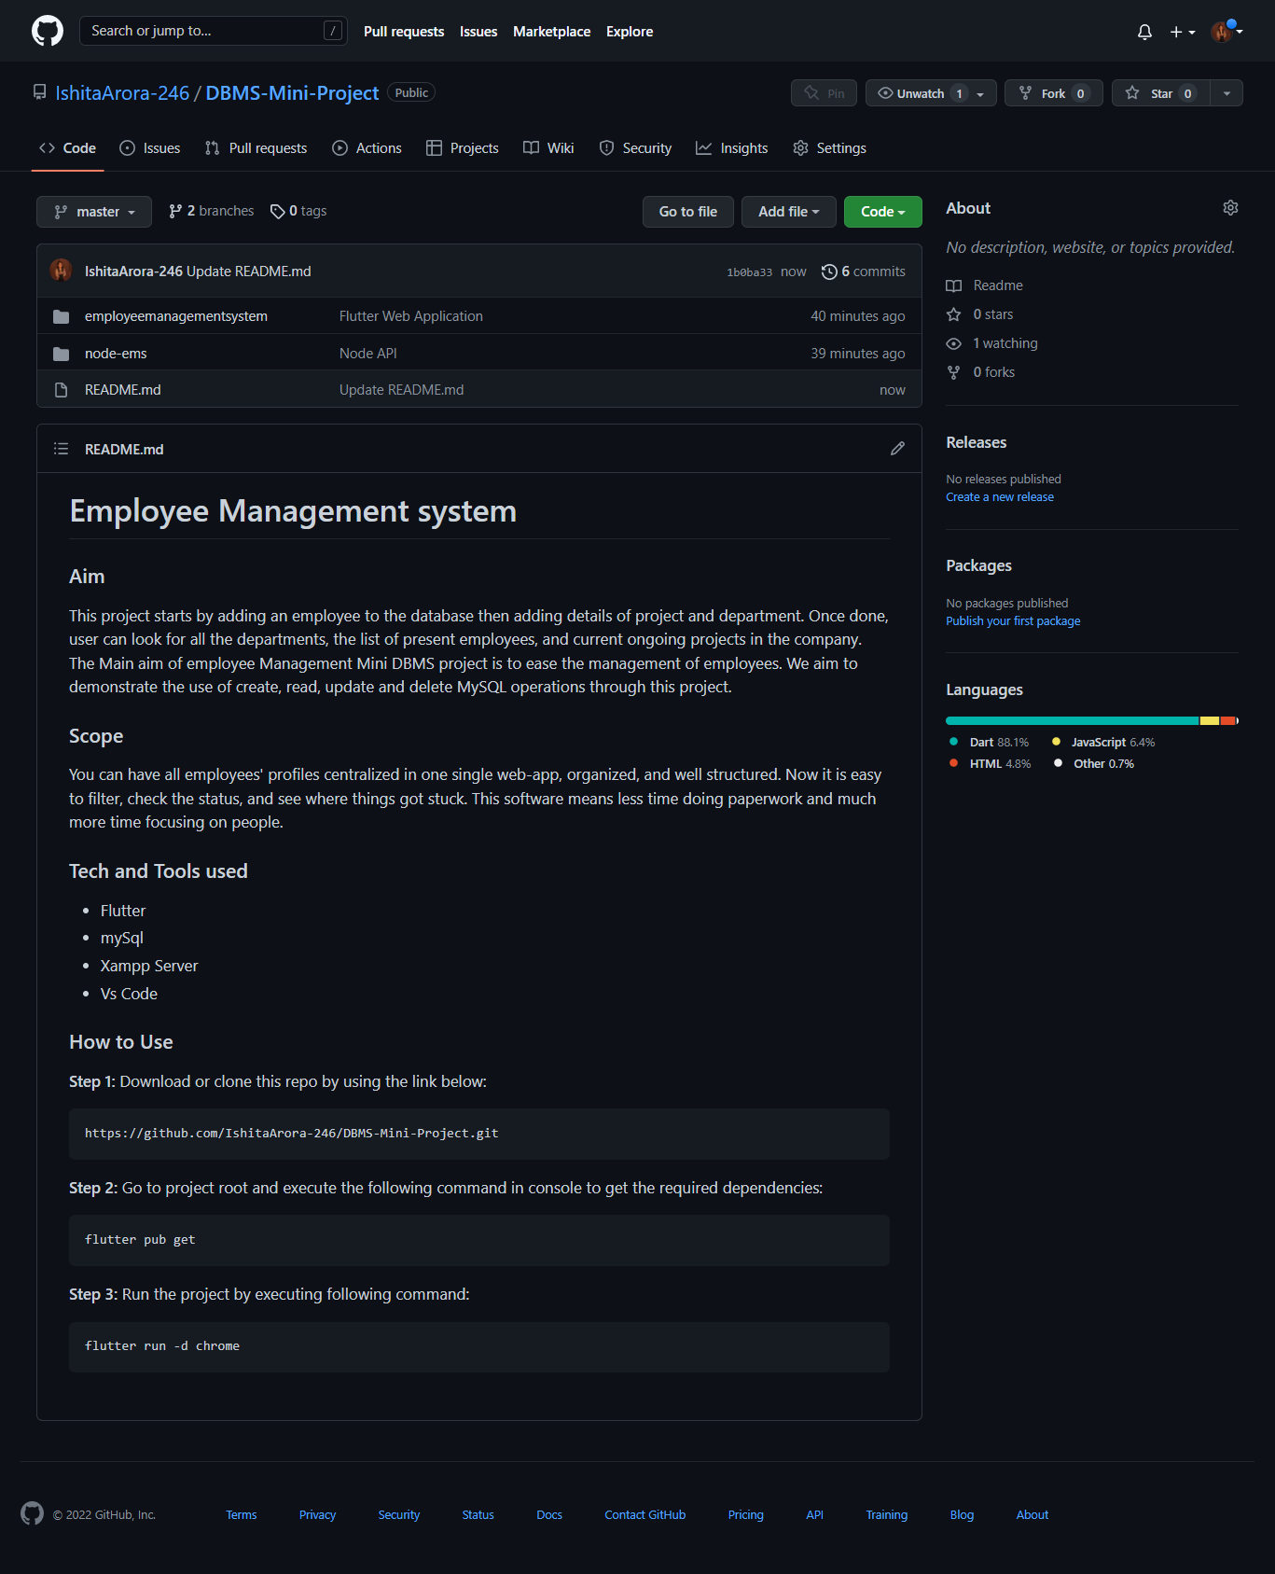

**Phpmyadmin Screenshots :**

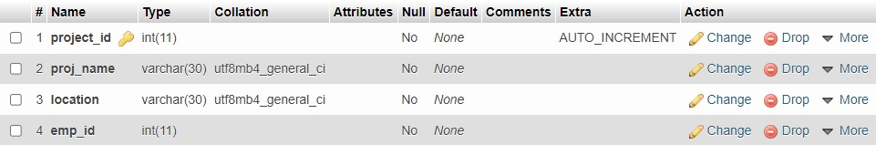

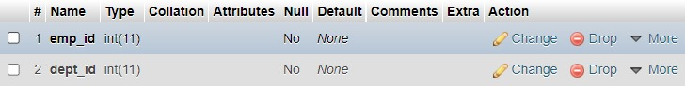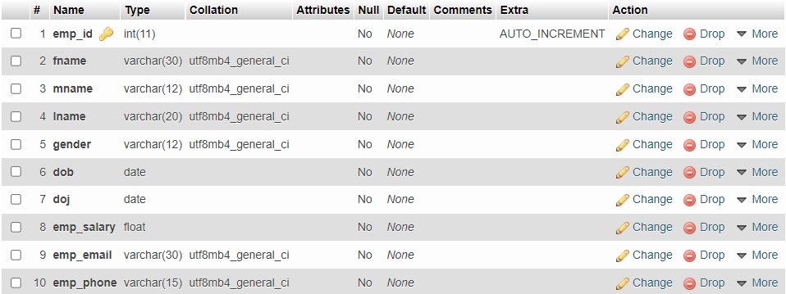

**Github Repo Link :**

[**h**ttps://github.com/IshitaArora-246/DBMS-Mini-Project](https://github.com/IshitaArora-246/DBMS-Mini-Project)